1 make menuconfig
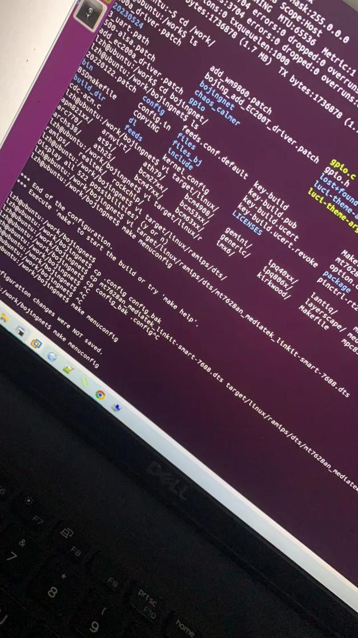
- 选择kernel module
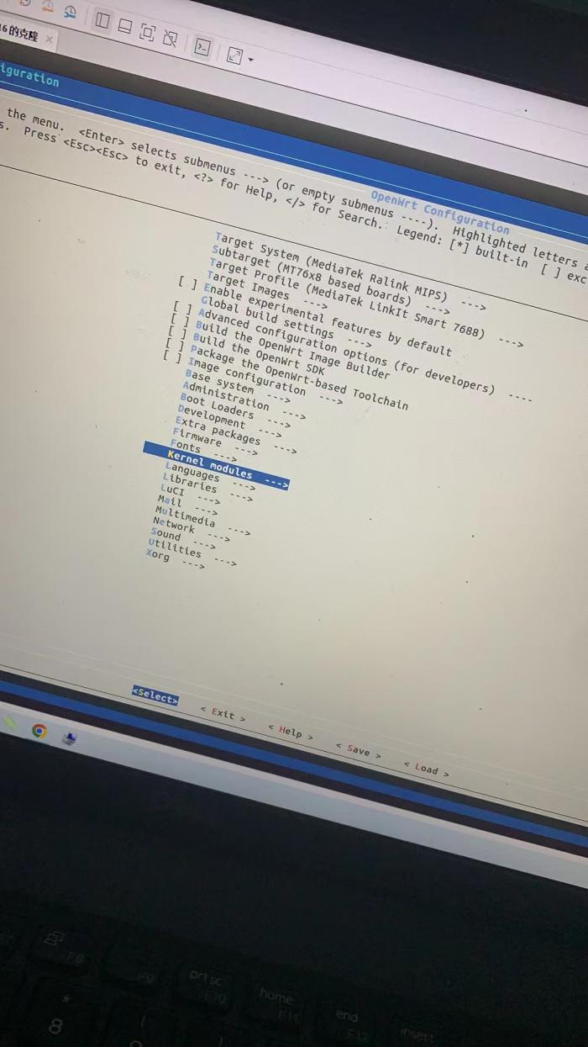
- 选择other module
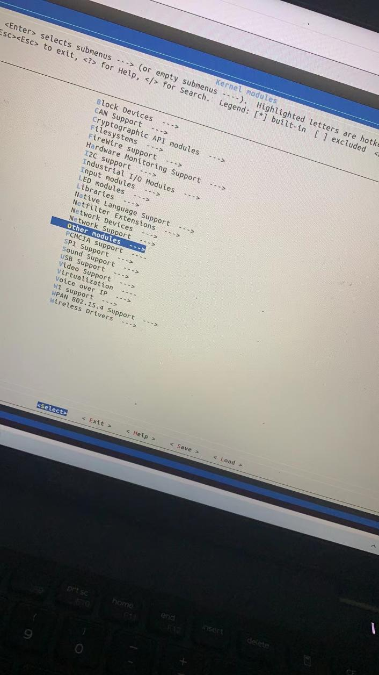
- 把kmod-sdhci-mt7620的驱动去除
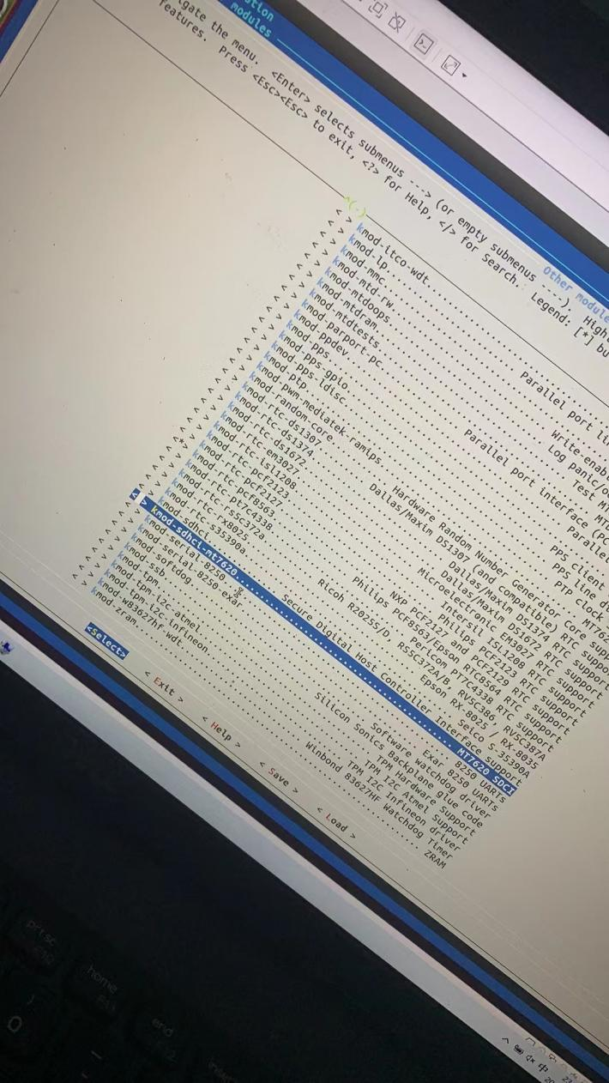
- 编辑 target/linux/ramips/dts/mt7628an_mediatek_linkit-smart-7688.dts
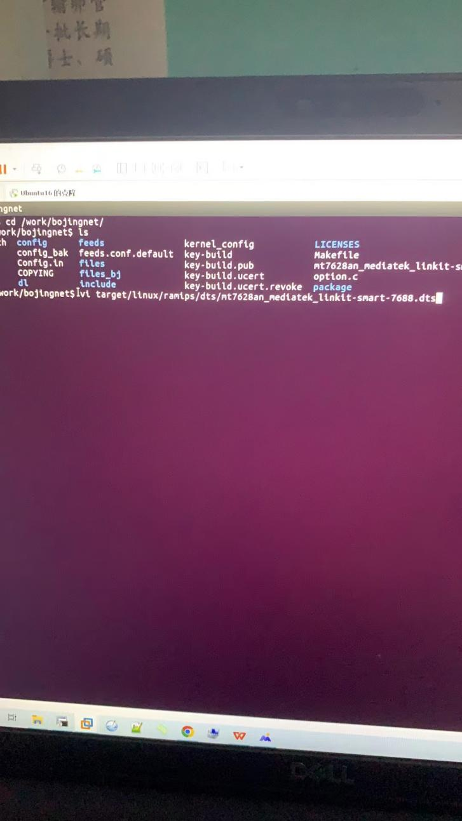
- 修改sdhci的状态为disabled
